 | Unscented | 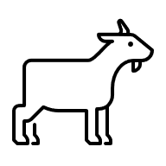  Farm Name | Unscented | Handmade Goat’s Milk Soap  Ingredients: olive oil, coconut oil, goat’s milk, lye.  Business Name  Business Address  Net Weight 4oz
 | Unscented | Farm Name | Unscented | Handmade Goat’s Milk Soap  Ingredients: olive oil, coconut oil, goat’s milk, lye.  Business Name  Business Address  Net Weight 4oz
 | Unscented | Farm Name | Unscented | Handmade Goat’s Milk Soap  Ingredients: olive oil, coconut oil, goat’s milk, lye.  Business Name  Business Address  Net Weight 4oz  Handmade Goat’s Milk Soap  Ingredients: olive oil, coconut oil, goat’s milk, lye.  Business Name  Business Address  Net Weight 4oz
 | Unscented | Farm Name | Unscented

